**ASSIGNMENT-1**

1. Find a student average mark given mark1 and mark2.

ALGORITHM

STEP 1: Start.

STEP 2: Declare variables mark1, mark2 and avg.

STEP 3: Read mark1 and mark2.

STEP 4: Add mark1 and mark2, then divide them by 2 and assign the value to avg.

avg 🡨 (mark1+mark2)/2

STEP 5: Display avg.

STEP 6: Stop.

FLOW CHART

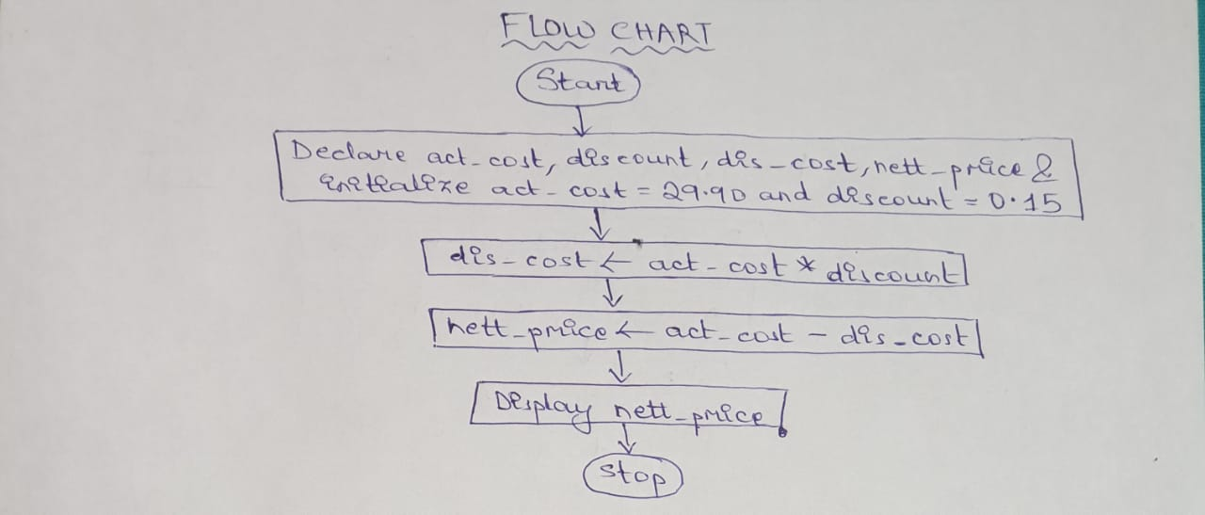

2. Calculate the total fine charged by library for late-return books. The

charge is 0.20 INR for 1day.

ALGORITHM

STEP 1: Start.

STEP 2: Declare variables t_fine, days_late, chr_per_day and

initialize chr_per_day = 0.20 .

STEP 3: Read days_late.

STEP 4: Multiply chr_per_day with days_late and assign it to t_fine.

t_fine 🡨 chr_per_day * days_late

STEP 5: Display t_fine.

STEP 6: Stop.

FLOW CHART

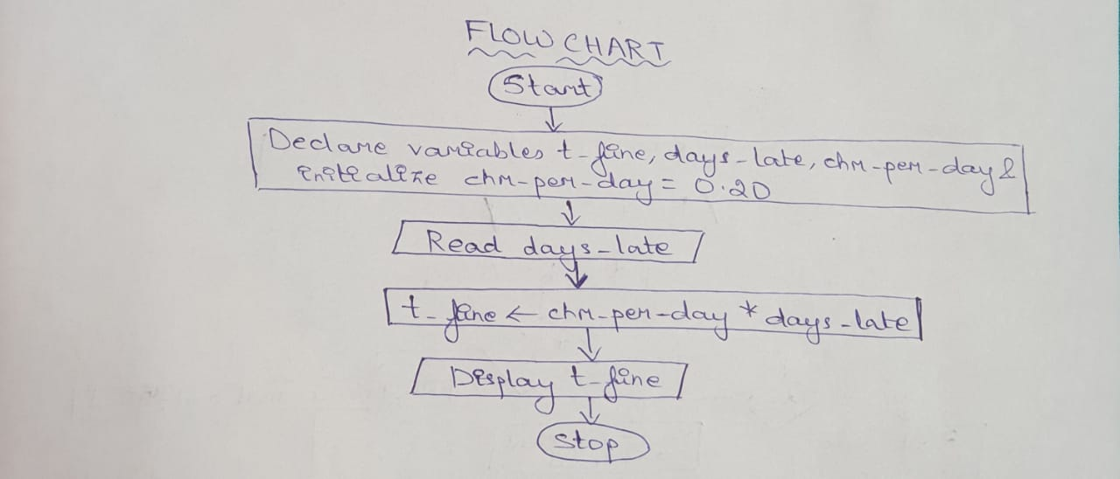

3. You had bought a nice shirt which cost Rs.29.90 with15% discount.

Count the nett price for the shirt.

ALGORITHM

STEP 1: Start.

STEP 2: Declare variables act_cost, discount, dis_cost, nett_price and

initialize act_cost= 29.90 and dis= 0.15.

STEP 3: Multiply act_cost with dis and assign the value to dis_cost.

dis_cost 🡨 act_cost * dis

STEP 4: Subtract dis_cost from the act_cost and assign the value to

nett_price.

nett_price 🡨 act_cost – dis_cost

STEP 5: Display nett_price.

STEP 6: Stop.

FLOW CHART



4. Find the smallest number among three different numbers.

ALGORITHM

STEP 1: Start.

STEP 2: Declare variables x, y and z.

STEP 3: Read x, y and z.

STEP 4: If x < y and x < z , then x is the smallest number.

STEP 5: Else if y < z , then y is the smallest number.

STEP 6: Else z is the smallest number.

STEP 7: Stop.

FLOW CHART

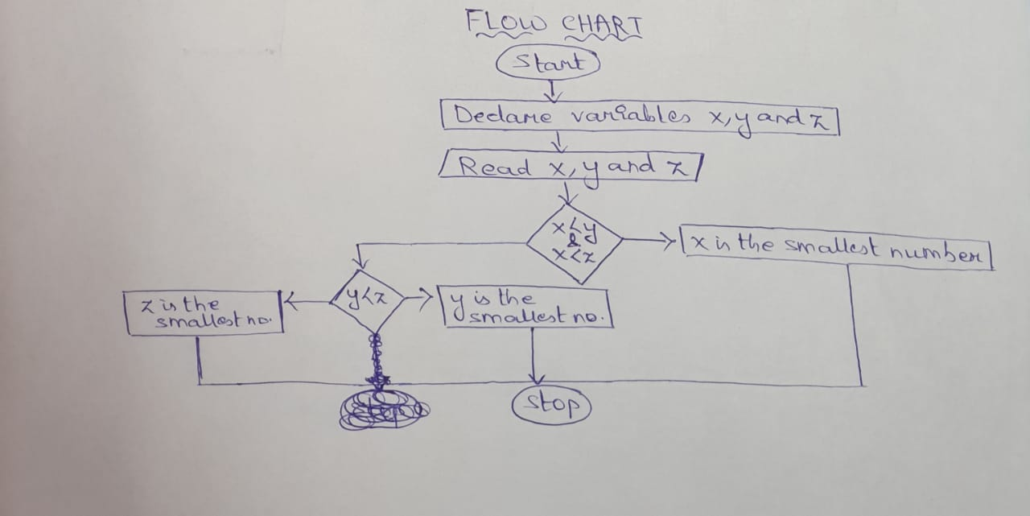

5. Find the Roots of a quadratic equation ax2+ bx + c = 0.

ALGORITHM

STEP 1: Start.

STEP 2: Declare variables a, b, c and d.

STEP 3: Read a, b and c.

STEP 4: Calculate d , i.e.

d 🡨 b2 – 4ac

STEP 5: If d > 0, then roots are real and unequal.

STEP 7: Else if d = 0, then roots are real and equal.

STEP 8: Else roots are imarginary.

STEP 9: Stop.

FLOW CHART

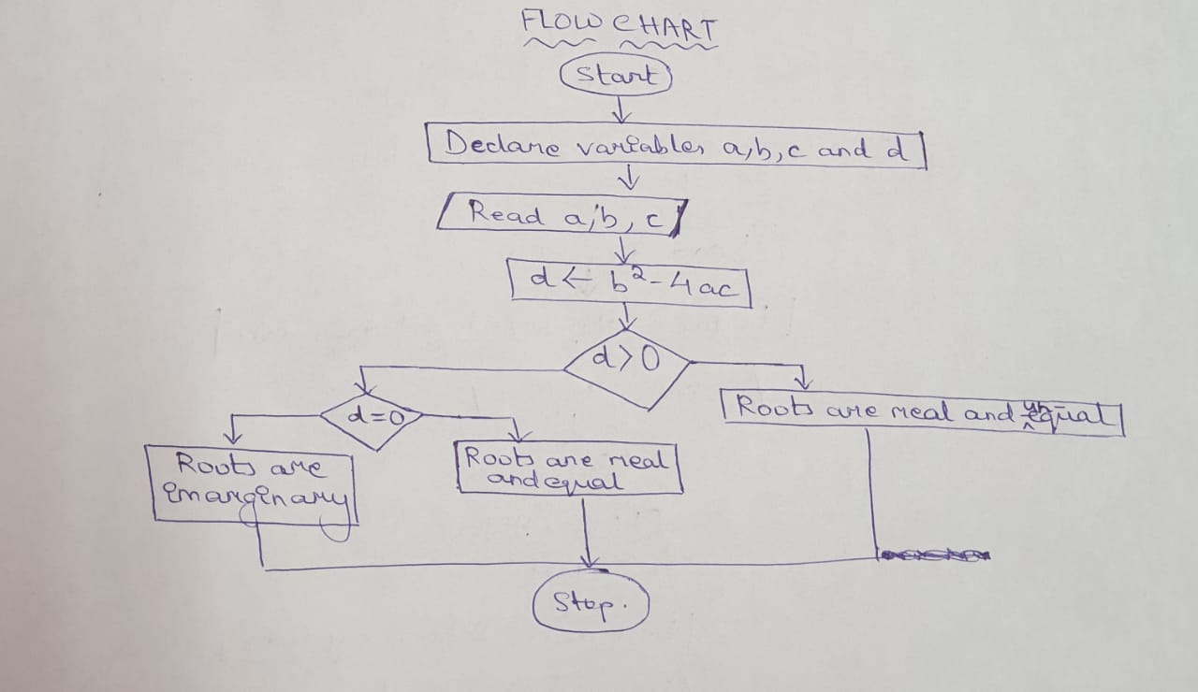

6. Find the factorial of a given number.

ALGORITHM

STEP 1: Start.

STEP 2: Declare variables num, fact and initialize fact = 1.

STEP 3: Read num.

STEP 4: fact 🡨 fact * num

STEP 5: num 🡨 num - 1

STEP 6: Repeat the above 2 steps until num > or =1.

STEP 7: Display fact.

STEP 8: Stop.

FLOW CHART

